
Solution tree diagram

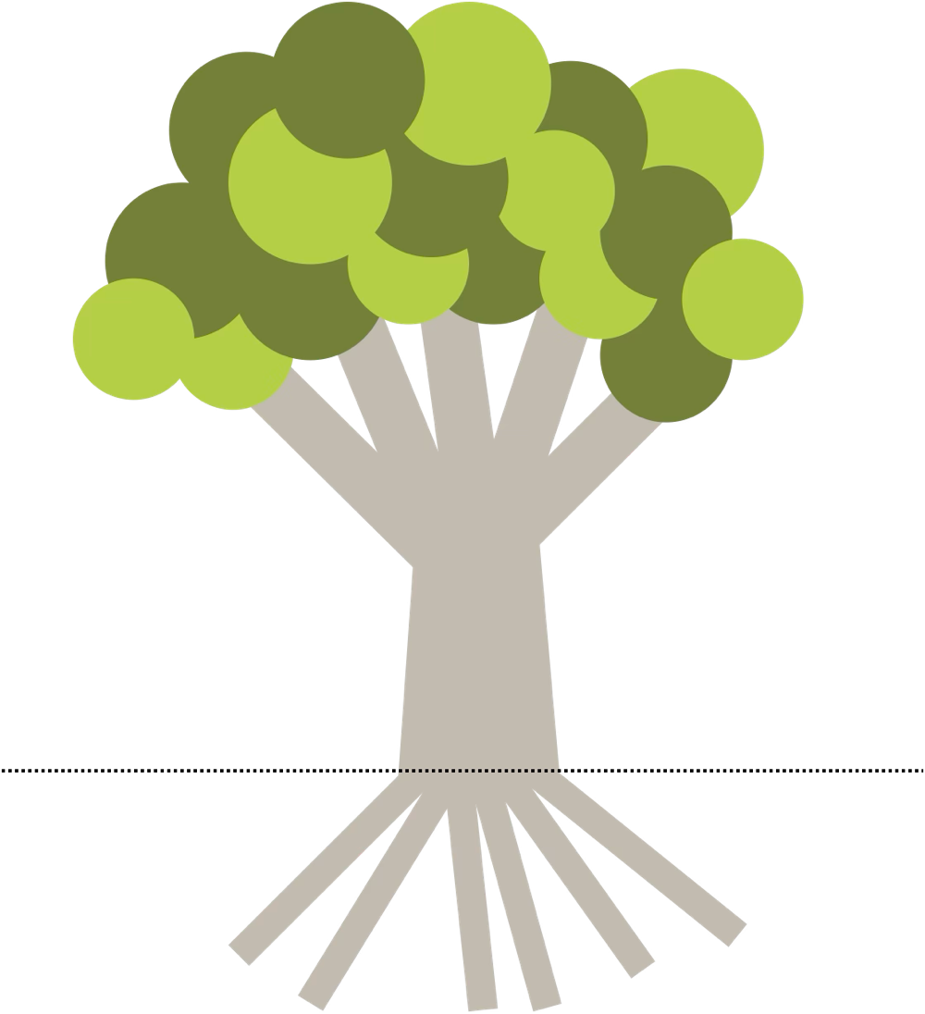







To use this tool, fill in the trunk with your vision: one sentence about the future you hope to achieve.

Fill in the roots with the actions that would make that vision real. This is where your research comes in: every solution you find becomes a root holding the vision up.

Then fill in the branches, the benefits that grow from those changes, like more students walking to school or fewer close calls at the crossing.

Together, roots, trunk, and branches turn a single idea into a picture you can act on.

