
Problem tree diagram

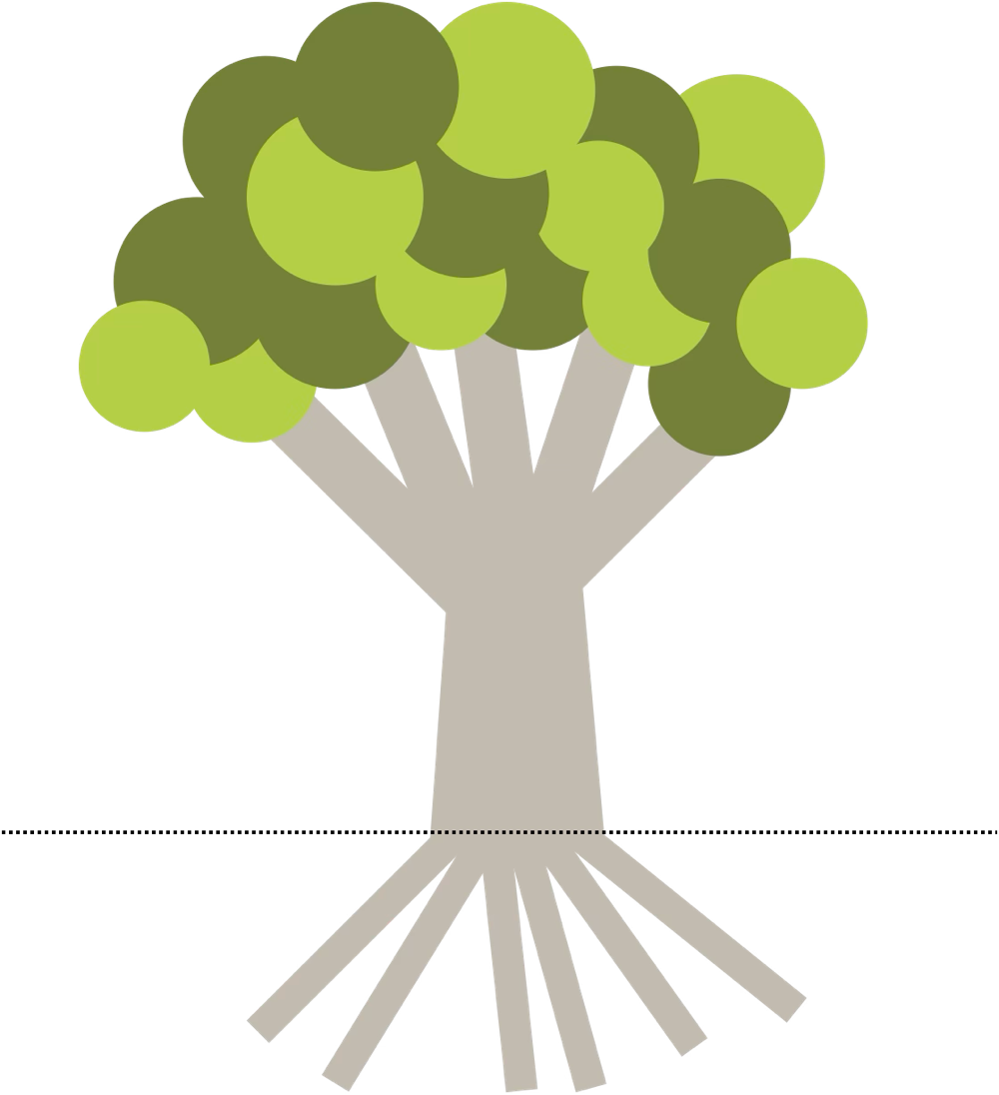



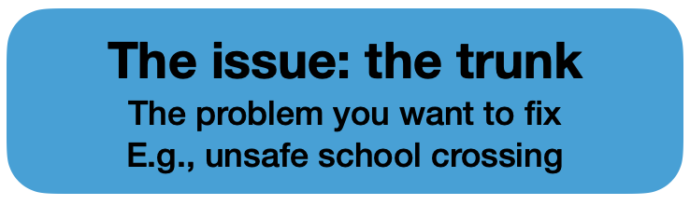



To use this tool, start by writing your issue on the trunk. This is your basis for everything.

The roots are the causes: why is this issue happening on a fundamental level?

The branches are the effects: what harm is it doing, and to whom?

A problem tree helps you see your issue clearly and explain it to others.

