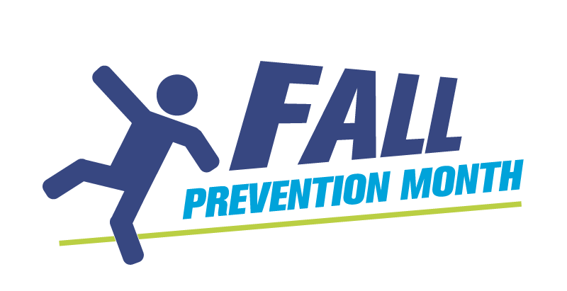
Fall Risk Factor Visual Brainstorming Activity

This activity can be used with older adults or staff members.

Activity steps

- Create a visual aid (example below) using bristol board or chart paper.
- Brainstorm the various risk factors for falls.
- Have your group write the risk factors right on the visual aid.
- Discuss potential interventions/tips on how to lower the risk of falls.
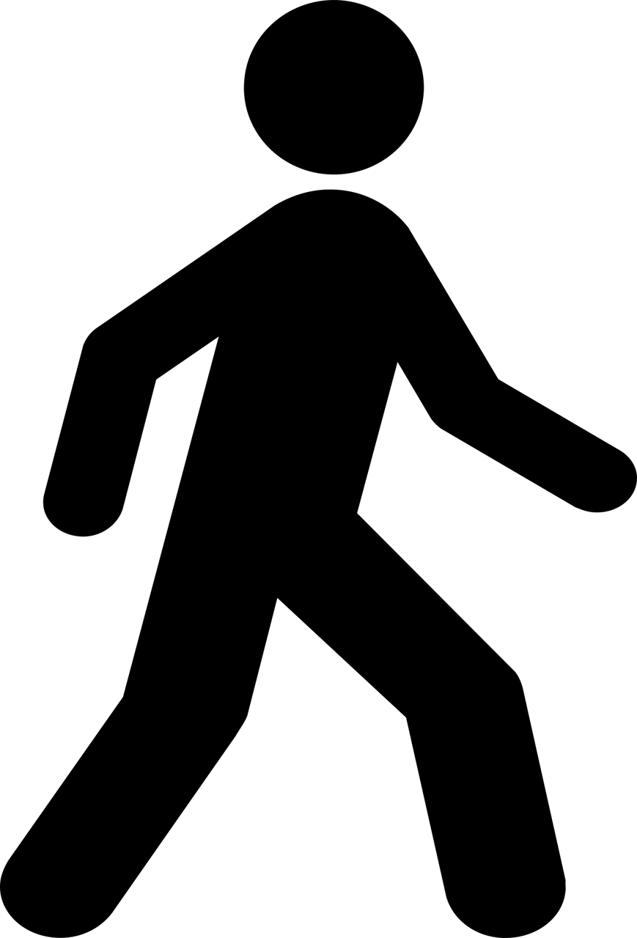
- Post your visual aid in a visible area and add to it regularly during Fall Prevention Month.
Pain
Impulsivity
Agitation
Medications
Nutrition
Infection
Stairs
n
Hearing
Uneven surfaces
Mobility
Footwear
Clutter
Environment
Urgency

Hydration
n
Flooring
Dehydration
Lighting
Confusion
Vision
Dizziness

