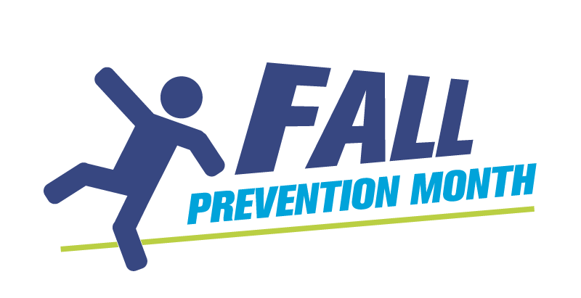
Mock Room Experience:
Spot the Hazards Activity Instructions

Set up a mock potential hazards room that outlines factors that contribute to falls. This can be for staff and/or the public in any health care or home setting. It is meant to be a station that people will walk through to identify the various fall risks within the room.

Discuss what interventions or changes that could be made to create a safer environment.

Variations:
- You can have people walk through with a handout and have them complete their findings or you can facilitate it in groups to engage people in dialogue about risk factors.
- You can set up a display with resources outside, make it a contest and promote this activity with posters and/or announcements. Encourage students and volunteers with various backgrounds to participate.
- Combine environmental risk factors with inherent risks for even more discussions.
- You can take pictures of your set up and use them with those that cannot attend in person.

Setting up the room

Suggested ideas for a clinical setting:
- Cluttered path
- Spill on floor
- Brake not on equipment and/or table or bed
- Sheets or blanket hanging off the bed loosely
- Cords
- Lighting too bright or too low
- Bed at a high awkward height
- Table far away from bed
Suggested ideas for a home setting:
- Rugs
- Pet toys
- Things set in high places, out of
reach
- Furniture that is unsteady
- Glare from windows
- Bed skirts hanging on the ground

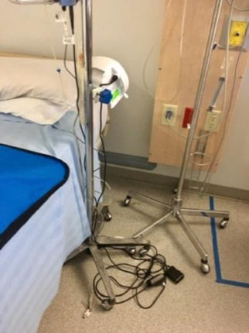
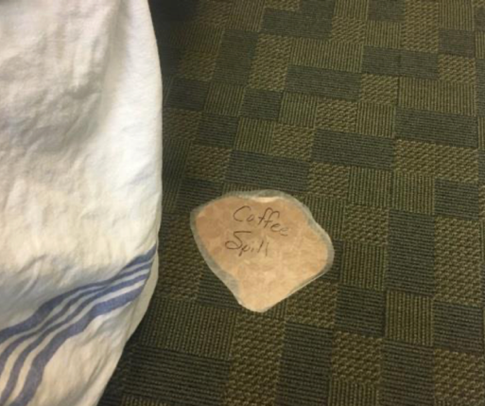
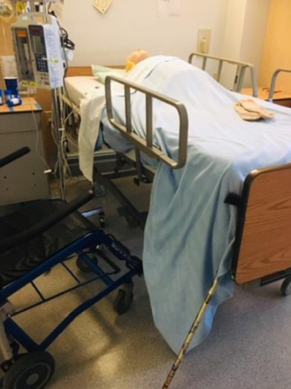
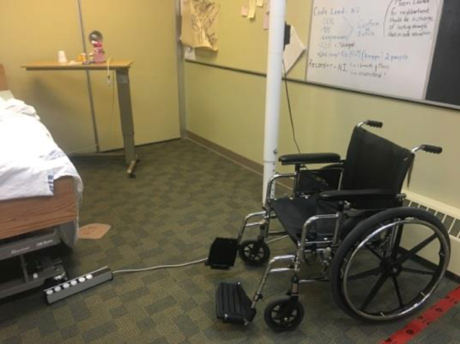
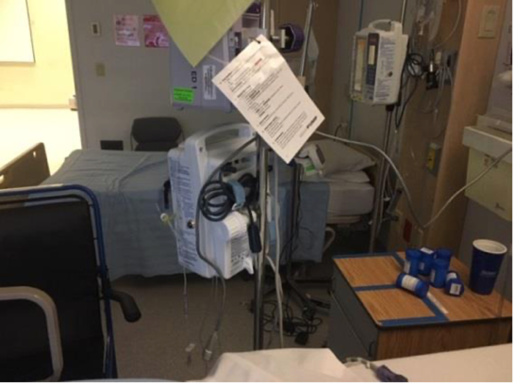
Examples:

Add in a scenario
Example – a patient profile:
Maggie is an 86-year-old female living with vascular dementia - admitted with dehydration, UTI, and a fall at home.
- PMHx: vascular dementia, stroke 2016 (mild left U/E weakness), glaucoma, diabetes, and arthritis.
- Medications: Antihypertensive, Diuretic, Dilaudid, and numerous over the counter medications. She has a hematoma to left side of face with minor skin tears to her arms. She typically uses a 4ww to mobilize and lives in Assisted Living.
Ask some key questions:
- What would you do to identify her fall risk factors?
- What biological or psycho/social factors may cause risk for falling? Please list.
- What environmental hazards did you identify in this patient’s room? Please list as many as you can.

