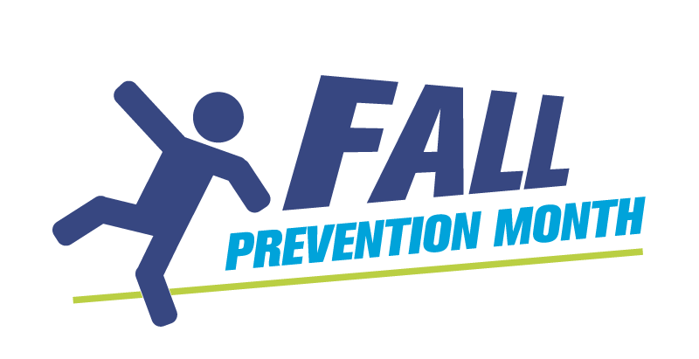


FALL PREVENTION

Come, have fun, join in and test your knowledge on how to prevent falls with a game of Fall Prevention Jeopardy!

Prizes will be awarded!

DATE:
LOCATION:
TIME:

