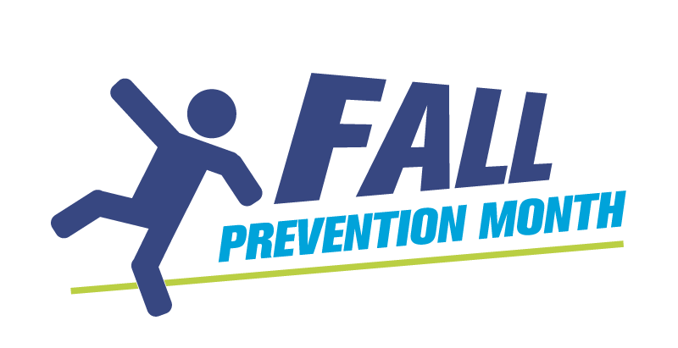
Vision and Safety:
Huddle Talk #2

Assessing for vision loss is more than a ✔️ checkbox!

Vision means different things to different people.

Diabetic retinopathy | Macular degeneration
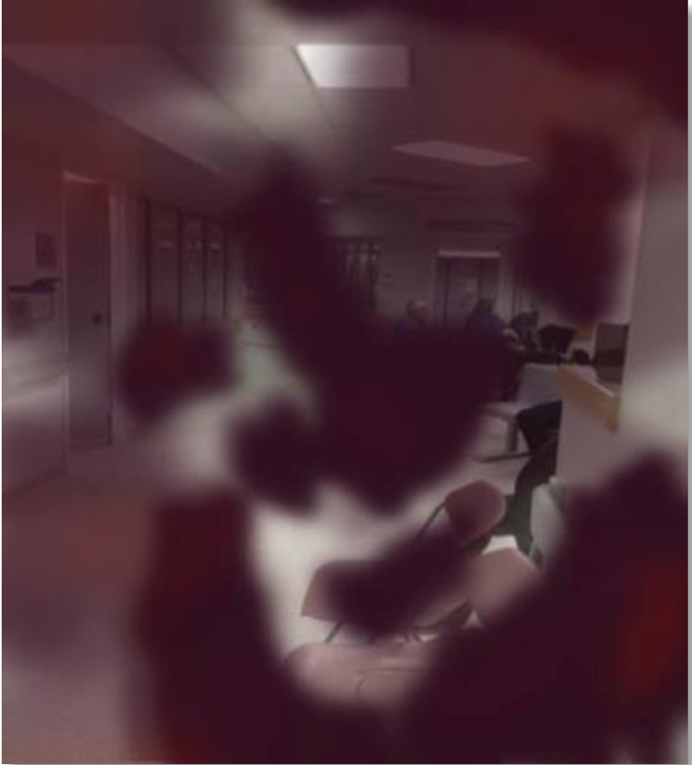 | 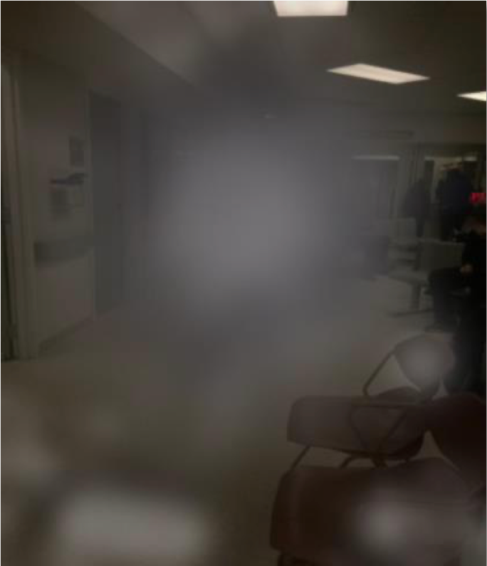

Let’s talk about what WE can do to create a safer environment.

Special thanks to CNIB for the photos.

