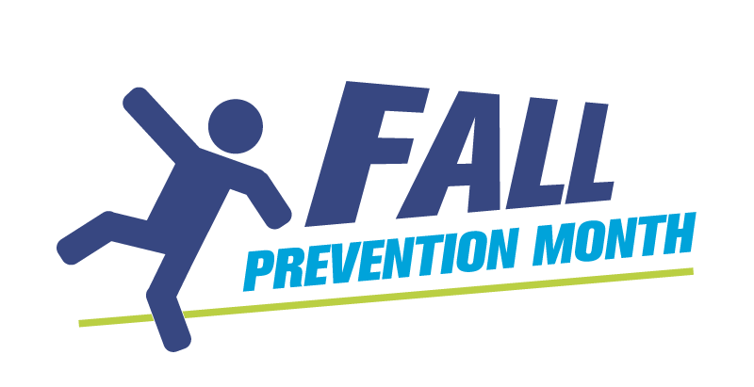
Vision and Safety:
Huddle Talk #1

Normal eyesight | Dense cataract impairing vision
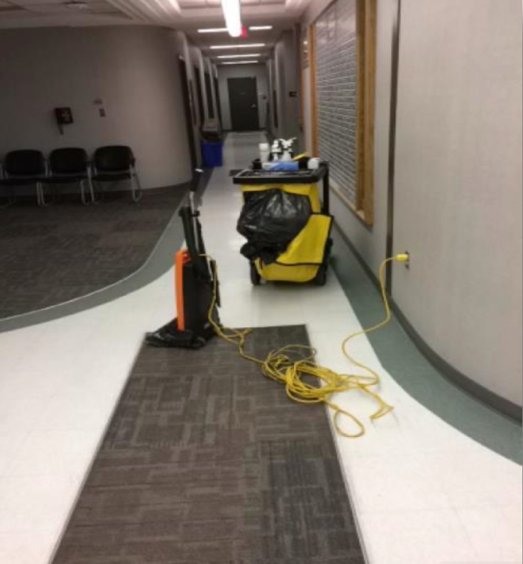 | 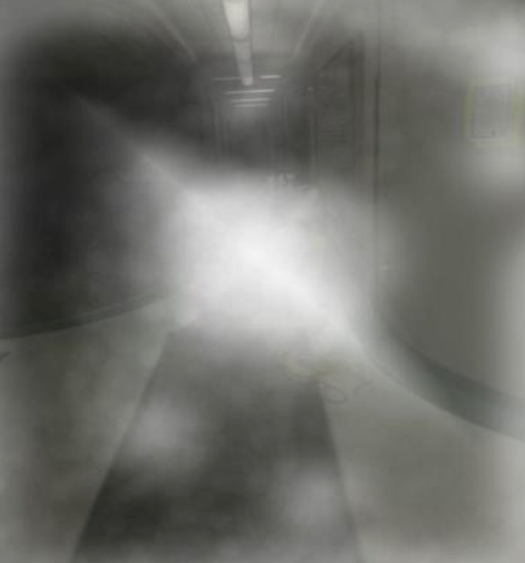

Let’s talk about what WE can do differently to prevent a fall in our environment.

Special thanks to CNIB for the photos.

