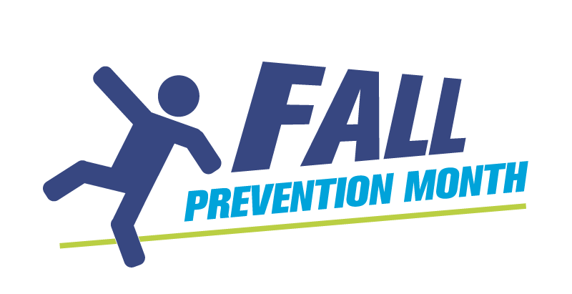
Social Media How-To Guide

Introduction

Social media is one of the most effective ways to share fall prevention information, increase awareness and encourage action during Fall Prevention Month and year-round.

Platforms such as Facebook, Instagram, X, Bluesky and LinkedIn allow organizations to reach older adults, parents, caregivers, childcare professionals, health professionals and communities across Canada. This guide outlines practical best practices to help you maximize your impact.

Facebook - https://www.facebook.com/

Facebook remains one of the most widely used platforms among older adults in Canada, making it a key channel for Fall Prevention Month messaging. It’s also effective for reaching parents and caregivers through community groups, parenting networks, daycare pages and local neighbourhood groups.

Goal: Each post should focus on one clear action such as reading a tip, visiting a webpage, registering for an event or sharing information.

Visuals: Posts with images or short videos consistently perform better. Use photos, short educational videos, infographics or campaign graphics whenever possible. You can add up to 10 photos or one video per post.

Engagement: Encourage interaction by asking questions, sharing practical tips or highlighting relatable scenarios.

Organic vs. Paid: Organic posts reach existing audiences. Paid promotion can help reach older adults, caregivers or local event participants. Even small budgets can improve visibility.

How to create an event for your Facebook page: https://www.facebook.com/help/116346471784004

X (formerly Twitter) https://x.com/

X is a real-time platform used heavily by health professionals, researchers, policymakers and media. It is effective for sharing timely information and joining national conversations.

Goal: Focus each post on one action such as link clicks, reposts or awareness.

Keep it concise: Short, clear messaging performs best. Lead with the key takeaway. X has a 280-character limit, so lead with your key message. You can include up to four images, one GIF, or one video per post.

Visuals: Images or simple graphics can improve visibility but should support the message.

Engagement: Increase reach by tagging partner organizations, participating in awareness conversations and sharing partner content. Tag organizations that work with families, childcare providers, schools or parenting networks to help reach caregiver audiences.

Hashtags: Use one to two relevant hashtags such as #FallPreventionMonthCA or #PreventFallsCA.

Paid promotion: Paid posts are generally less effective on X for awareness campaigns and are not typically necessary.

Bluesky https://bsky.social/about/

Bluesky is a newer platform for public conversations and short posts, gaining traction among professionals and community organizations. It is effective for sharing tips, updates and promoting events.

Goal: Focus each post on one action, such as link clicks, sharing a tip, or raising awareness.

Keep it concise: Short, clear messaging performs best. Bluesky posts are limited to 300 characters. You can include up to four images or one video per post.

Visuals: Images, graphics, or short video clips help posts stand out and illustrate your message.

Engagement: Increase reach by tagging partner accounts, participating in conversations, and encouraging replies and shares.

Hashtags: Use one or two relevant hashtags, e.g., #FallPreventionMonthCA or #PreventFallsCA.

Paid promotion: Paid posts are not widely used on Bluesky and are generally unnecessary for awareness campaigns.

Instagram https://www.instagram.com

Instagram is a highly visual platform ideal for education, storytelling and community engagement.

Goal: Encourage interaction through likes, comments, saves and shares.

Visuals: Use photos, Reels, educational carousels and tips or statistics. Short-form video continues to see the strongest engagement. Each post can include up to 20 photos or videos in a carousel, or one video/Reel.

Engagement: Test different formats to learn what resonates with your audience. Authentic, practical content typically performs best. Parent and caregiver audiences respond well to short videos demonstrating safety tips for infants and young children, such as safe play spaces or supervision reminders.

Organic vs. Paid: Instagram ads can effectively expand reach, especially when paired with Facebook advertising through Meta Ads Manager.

Hashtags: Use multiple relevant hashtags (up to five) such as #FallPreventionMonthCA, #PreventFallsCA, #FallPrevention, #TurnSafetyOn, etc.

Important: Captions can be up to 2,200 characters, but the first 125 are critical for engagement.
LinkedIn https://www.linkedin.com/

LinkedIn is a professional network used by health professionals, caregivers, researchers and organizational leaders. It is ideal for sharing educational content, program updates, and event invitations.

Goal: Focus each post on one action, such as reading an article, registering for an event or sharing a tip.

Keep it professional: Posts should be clear, informative and practical. Lead with the main message.

Visuals: Include photos, event posters, infographics, or short videos to illustrate your point. Posts with visuals perform better. You can now add up to 20 images to a single LinkedIn post.

Engagement: Encourage comments, shares, and tagging of partner organizations to extend reach.

Hashtags: Use one to three relevant hashtags, e.g., #FallPreventionMonthCA, #PreventFallsCA, #TurnSafetyOn.

Paid promotion: Sponsored posts can expand reach to specific audiences, such as senior care professionals or caregivers, but are optional.

General best practices (all platforms)

• Keep messages clear and actionable
• Use plain language
• Prioritize practical prevention tips
• Post consistently
• Share and amplify partner content, tag accounts
• Include links to trusted resources
• Ensure visuals reflect diverse older adults and communities

