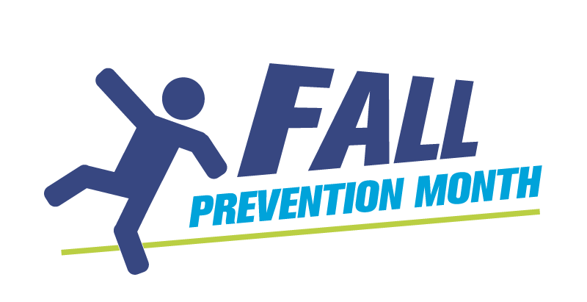
Fall Prevention Month:
How to host a webinar
A webinar is an online video event that helps you engage with your audience for a variety of purposes, including workshops, virtual games and educational presentations. Learning how to host a webinar will be especially helpful if you are planning to run an activity in a virtual setting for Fall Prevention Month.
There are various platforms you can use to host a webinar. Zoom and Google Meet are two common platforms that allow webinar hosting. Visit their Help Centres to learn how:
Zoom: https://support.zoom.us/hc/en-us Google Meet: https://support.google.com/meet
Note that there are restrictions on free accounts for these platforms. You need a paid account to set up a webinar on Zoom. The Google Meet free account allows you to host a meeting for up to 100 participants, but they must be invited to the meeting: there is no sign-up function and the event can’t be recorded without a screen recorder extension.

Tips for hosting a webinar
Preparation

- Decide the audience, topic and objectives of the webinar.
- Based on the above, decide who is speaking or presenting on the webinar and confirm their availability.
- Pick your date and time.
- Book your Zoom or Google Meet line. If more than you use this line, book a 30-minute buffer time on the line around your event so no-one else books a meeting immediate before or after on the same line.
- Invite the speakers or presenters to the event, along with anyone who will be on the session for technical support or to take notes. Set these team invitations for 15 minutes prior to when the webinar is scheduled to start so you have time to iron out any technical difficulties.
- Create any presentations or slides to share during the webinar. Include a placeholder slide for the beginning with the words “This webinar will begin shortly.”
- Create your post-event evaluation survey, if you plan to use one.
- If your webinar includes a Q&A period, you may want to prepare one-to-two questions to have on hand in case participants don’t have any questions for the speakers.

Attracting attendees
- On Zoom, you can create a webinar event page that you can then promote to allow people to sign up. Alternatively, you can share the webinar link directly through an email invitation if this will be a by-invitation-only event.
- Promote your event through social media, newsletters, e-blasts – however you usually communicate with your audience. Consider designing a poster-style promotion piece to share.

On the day of the webinar
- Before you start the webinar, take two minutes to introduce the participants to the technology, such as how to ask a question, and respond to their questions. Let them know if a recording of the webinar will be made and sent to participants, or not.
- Once you have introduced the technology, walk the participants through the purpose of the webinar, the process or goals, and introduce any speakers you may have.
- Decide when and how you want your participants to ask questions and let them know early on in the webinar. For example, should they use the Q&A box or the chat room? Will the Q&A take place in the middle of the webinar or at the end?
- Assign a colleague to respond to technical questions during the webinar through the chat room or by direct email. Your colleague can be prepared with responses to common questions or concerns such as, “I can see the speakers, but I can’t hear them.”
- If you want to evaluate your event or webinar, provide a form at the end of the webinar. Alternatively, send a follow up email to participants with a survey and thank them for attending. Keep the survey short: between three and five questions.
After the webinar
Send a thank-you email to guest speakers.
If you have recorded the webinar, you can download it and share the link with participants, both those who attended and those who had registered, but were unable to attend. You may want to edit the webinar, cutting out the opening couple minutes of technical explanations and the time when the host is waiting to begin while people continue to join the session.
If you want the webinar to be viewed more widely, you will need to post the webinar on a platform such as YouTube and make that link publicly available.
Download the post-webinar reports from your platform, such as Zoom. Note how many people registered and how many people attended. Compile your evaluation data, if you are collecting it.

