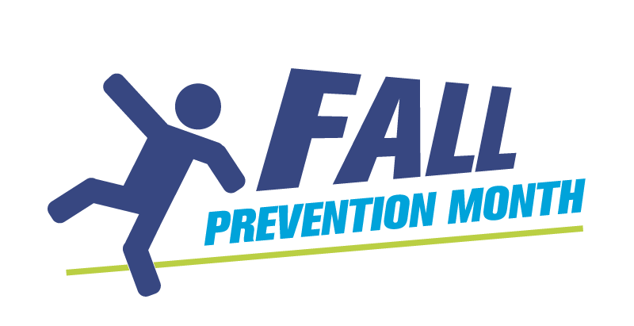
How to engage Communications Departments
If you work in an organization that has a Communications Department, connect with them early to discuss the importance of being involved in the Fall Prevention Month campaign from the perspective of your entire organization. Here are some tips to help you engage with your communications colleagues so they can help you raise awareness of fall prevention during November’s Fall Prevention Month campaign.
Do your research
Take a look at your organization’s communication platforms, such as your website and social media platforms, so you can familiarize yourself with the type of information that the organization shares. It’s also important to understand how Fall Prevention Month fits into your organization’s mandate and messaging, so you can demonstrate that your message is relevant to the communications team.
Practise your pitch
Similar to pitching to the media, make sure you can share your message concisely. Be clear about how fall prevention is relevant to your organization and why sharing content is a good fit for your messaging and values. Do this via email first and then follow up by phone or a personal meeting a few days later.
Ask early and remind
Reach out at least two months in advance – in September, once Labour Day weekend is past – to start the conversation. A busy communications department may need to engage other decision makers and seek approval from leadership. Once the comms team has agreed to promote Fall Prevention Month, send a follow-up reminder to your communications colleagues. For example, you can send a brief email stating that you’re grateful and excited to have their support in raising awareness of fall prevention and reiterate the details about you’re your organization will be doing.
Be specific
Start off by asking if they would be willing to do something specific, such as share three social media posts during November. Depending on their response, you may find that they are very interested and want to do more. Examples of information you can provide the communication department include:
- Statistics from the Fall Prevention Month Fact Bank
- What activities are being planned by your organization
- Fall prevention services you provide and want to promote
- Various Fall Prevention Month resources available to share, such as posters, videos and graphics.
Make it easy
Think about what you’re asking them to do and make it easy. If you want them to share three posts in November, send them the post graphics, text, hashtags and the dates you would like them to share those posts. Of course, make it clear that you understand that the dates may need to be adjusted based on your organization’s full social media schedule.
If you want to share your own organizational resources with the Fall Prevention Month logo, please include the branding instructions on the use of the logo or provide your resources with the Fall Prevention Month logo already in place.
Say thank you
After they complete what you’ve asked them to do, send a thank-you email and reiterate why their involvement is important. It’s also never too early to start planning for next year, so let them know that you hope they’ll be involved next year.
Circle back
After Fall Prevention Month is over, check in with your communications colleagues. Ask them what kind of engagement and metrics they received from the Fall Prevention Month content and celebrate your joint success.

