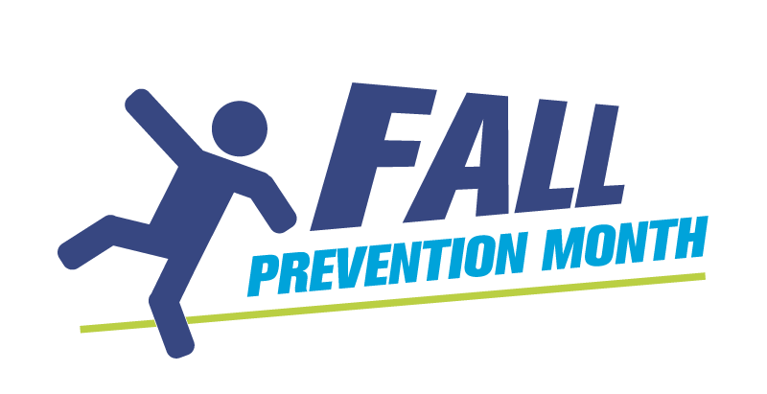
Accessibility Guide
By making information easier to access, more people can be involved with Fall Prevention Month and related activities.
Canadians of every age may need accessible information. For example, additional visual and auditory options can be helpful to a 22-year-old who is deaf or has a hearing impairment, a 30-year-old who is autistic or on the autism spectrum and older adults in their 80s who have a visual impairment. For example, high contrast between text and the paper colour (e.g. black on white) may make a document more accessible for someone with a visual impairment and a person who is on the autism spectrum.
There are a few elements to consider when creating accessible materials. Most importantly, always ask your target audience how they would like to receive information. Never assume. No audience is homogenous, but you may discover patterns.
Examples of accessible formats
- Websites optimized for screen readers
- Accessible Word document
- Accessible PDFs, a format known as PDF/UA
- Braille (for visually impaired)
- Large print
- Subtitles or descriptive audio for video
Language
- Speak and write clearly without jargon or negative language (Use “Do” instead of “Do not”).
- Write short sentences.
- Write for a Grade 6 reading level. Most word-processing programs have built in grade-level calculators, known as the Flesch-Kincaid Grade Level. This document, for instance, is at a Grade 10 reading level.
- Use second-person language to refer to the reader, and first-person language to refer to your organization: e.g.: “If you have a disability, contact us at info@program.ca”, rather than “People with a disability can contact the program at info@program.ca.”
- There are exceptions and differences in some deaf and autism spectrum communities. For example, in both communities, some people believe that autism or deafness is an integral part of who they are and they want to be identified by that characteristic.
- Use language that recognizes independence, competence and experience such as “older adults” or “seniors” rather than “elderly”. Understand your particular audience and their preferences.
Assume independence
- Speak with or consult rather than tell.
- Ask what is needed rather than assume (e.g. video with captions instead of a document).
- Encourage independence by providing easy-to-access information.
Format for documents
If the information you want to share can be put directly on a website – using what’s known as “HTML formatting” – rather than in a downloadable document, do so. People with visual impairment can use a screen reader to access the information. However, if you need to post a document on a website, follow these guidelines:
- Remember that regular PDFs can’t be read by a screen reader. To be accessible to someone who uses a screen reader to access online information, PDFs must be remediated (adding markup and tags) and saved in the PDF/UA format. Consider using an accessible format, such as Word, if your document is primarily text.
- Use headlines and sub-headlines to separate information.
- Use colours that provide high contrast (e.g. dark blue and white). Many people who are colourblind can’t tell red and green apart. Most document software has accessibility checkers that can review your choices and flag if anything is inaccessible due to colour choices or poor contrast.
- Use simple sans serif fonts that are easily available, such as Arial or Helvetica.
- Use a larger font size, which is measured in “points.” 12-point fonts are often suitable.
- Put extra space between lines, such as 1.15 instead of 1.
- Keep photos, graphics and tables to a minimum and include alt text when posted online. Alt text (alternative text) is text that describes and conveys the meaning of an image, chart or other visual non-text item.
- Create printer-friendly documents with no more than two decorative colours, if necessary, and keep the background white and text black.
- Consider how your documents will be seen on different digital platforms, such as desktops, mobile phones or tablets.

Resources and guides
Government of Canada – Making documents more accessible
https://www.canada.ca/en/employment-social-development/programs/accessible-canada-regulations-guidance/alternate-formats/making-documents-more-accessible.html
Government of Ontario — Accessibility Laws
https://www.ontario.ca/page/accessibility-laws
Toronto Metropolitan University — Accessible Documents
https://www.torontomu.ca/accessibility/guides-resources/document-accessibility/
Queen’s University Accessibility Hub — Accessible Documents
https://www.queensu.ca/accessibility/how-info/accessible-documents
Microsoft Word — Make your Word documents accessible to people with disabilities
https://support.microsoft.com/en-gb/office/make-your-word-documents-accessible-to-people-with-disabilities-d9bf3683-87ac-47ea-b91a-78dcacb3c66d
Canadian Association of the Deaf: Terminology
https://cad-asc.ca/our-work/terminology/

