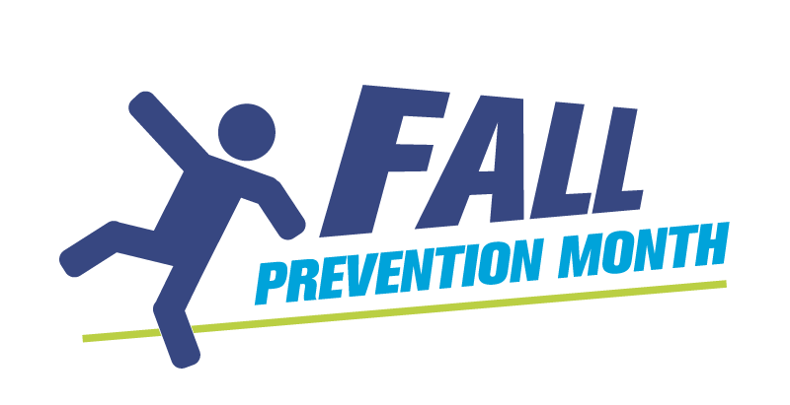
Identifying Risk Factors to Fall
A to Z Display Template

Falls occurs because of complex interacting risk factors that cause inability to recover balance. Create an A to Z wall display. Each day will be a new letter of the alphabet for you to explore with your team, identify risk factors for falls and place them on the display for all to see. You can add to it and discuss them at your wall. This can also be done as a group activity with older adults in various settings such as LTC, with staff or individually. You may use small note pages or this template.

Examples: A for Arthritis, anxiety; B for Balance deficit; C for Chronic conditions, Cognitive impairment

A. | G.
B. | H.
C. | I.
D. | J.
E. | K.
F. | L.

M. | T.
N. | U.
O. | V.
P. | W.
Q. | X.
R. | Y.
S. | Z.
Identifying Risk Factors to Fall A to Z Sample Responses
The following answers you can use to prompt the identification of even more risks. This is not an exhaustive list. There are over 400 identified risk factors that in combination with each other contribute to falling.

A | age, arthritis, agitation, acute illness, alcohol, assistive devices
B | balance problems, behaviour (risk-taking)
C | cognitive impairment, cardiac, confusion, clutter, clothing
D | drugs, diabetes, dementia, dizziness
E | elimination, environmental hazards, equipment in hallways
F | fall history, foot disorders, footwear, flooring, fear of falling
G | gait deficits, gender, glare
H | hydration, heart disease, handrails (inappropriate), hearing
I | incontinence, illiteracy
J | judgement (poor), jitters
K | kick-space lacking under bed
L | lack of exercise, lonely (live alone), language barriers, lighting
M | mobility
N | nutrition (poor)
O | osteoporosis, obstacles in the way
P | Parkinson’s disease, postural hypotension, prescriptions
Q | quadricep strength
R | rest areas (not available), restraints, risky behaviour
S | stroke, stairs, support (lack of), substance use, social isolation
T | trip hazards, transportation (lack of)
U | uneven surfaces, unsafe/unfamiliar environment, urgency/frequency (bladder/bowel)
V | visual deficits
W | weakened muscles, wet floor, wandering
X | refleXes (ha, ha) slower
Y | yapping (distracted)
Z | zzz (sleepy or lack of sleep), zopiclone

Submitted by Saskatchewan Health Authority, Saskatoon Area

