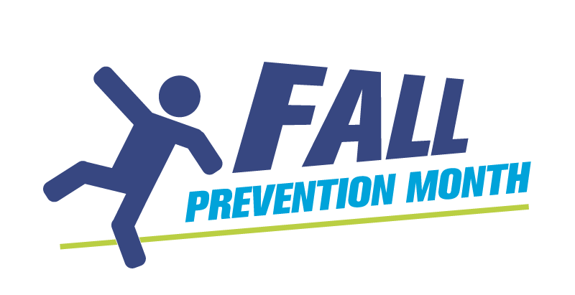
Interventions to Reduce Risk Factors A to Z Display Template

Falls occur because of complex interacting risk factors that cause inability to recover balance. Create an A to Z wall display identifying interventions to address the risks. Each day will be a new letter of the alphabet for you to explore with your group, identify risk factors for falls and place them on the display for all to see. You can add to it and discuss them at your wall. This can be done as a professional team activity or as a group activity with older adults in various settings such as long-term care. You can use small note pages or this template.

Examples: A for Activity; B for Bed height; C for Check clothing

A. | G.
B. | H.
C. | I.
D. | J.
E. | K.
F. | L.

M. | T.
N. | U.
O. | V.
P. | W.
Q. | X.
R. | Y.
S. | Z.

Interventions to Reduce Risk Factors A to Z Sample Responses
Below are examples of interventions based on the alphabet that can be discussed, posted for display and/or put in place in a care plan based on a person’s individual risk factors. This is not an exhaustive list.
A | activity, assessment, address mood (e.g. anxiety), alarm use, anticipate needs to reduce client doing “unsafe” self-help
B | brakes on bed and equipment, bed height, busy blanket use, bedding tucked in
C | clutter-free rooms, calcium, communication, clothing (proper fit, easy to put on/remove), contrast tape on steps, call (for help), chair exercises
D | diversional activities, dental checks, develop a plan of action, décor changes for safety (e.g. consider rug patterns, soft flooring)
E | environmental assessment, education, explore infections/changes
F | footwear (available and in use), foot care, fall mats, family
G | glasses easily available, gait aides
H | hearing aids, hydration, huddles, hip protectors, healthy eating, handrails
I | involve family in care planning
J | joint relief (address discomfort), jacuzzi tub for comfort
K | know your client, keep things in reach
L | lower bed, language (simple/brief), least restraint, lighting
M | medication review, music, movement, motivate, motion sensor lighting
N | non-slip socks, nutrition, night light
O | observe for changes in patient’s condition, orthosis, oral care for healthy eating, orientate client to surroundings often
P | pain control, purposeful interactions, positioning, patience, positive encouragement
Q | quarterly medication reviews, questions before leaving room
R | regular safety checks, referrals, rounding, routine (know the person’s routine), review of meds, review of care plan, reaching tools available, raised toilet seat
S | scheduling (medication timing, sleep, toileting), stretching, support, spills wiped
T | toilet regularly, transfer belts, tests for further inquiry, Tai Chi, twiddle muffs, team (include everyone), time of day recognition (when are they most disoriented)
U | understand patient’s risk factors, use of call bell, urban poling
V | vison checks, visual aids, vitamin D
W | walking aids, wheeling/walking (stay active), 5 w’s: why, what, where, when, who, weighted or warm blankets
X | xerostomia (dry mouth)- keep water close by and accessible, x-ray (further investigate symptoms)
Y | yoga
Z | Zumba (can do even at wheelchair level)

Submitted by Saskatchewan Health Authority, Saskatoon Area

