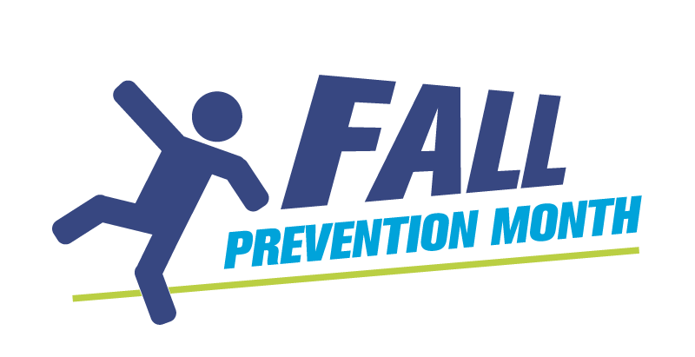
How to write and share a news release
Before you start writing
Clarify your goals
Ensure you understand the sole purpose of your news release before you begin writing. Typically, the goal will be media coverage. However, are there other goals to consider such as brand awareness or social media mentions?
Understand your subject matter
After you send your news release to the news desk or a specific reporter, you may receive questions from the media. Make sure you understand the topic well and are prepared to speak confidently to journalists if required.
Think about your audience
Take time to consider who your audience is. Ask yourself which reporters, media outlets and community members will be interested in this information. Build a targeted media contact list so you can reach the right audience.
Optimize your timing
Avoid sharing your news release on or around holidays, special events or national celebrations. For instance, during Fall Prevention Month held in November in Canada, most outlets will be focused on Remembrance Day, and stories that discuss veterans’ issues, immediately before and on Nov. 11. Avoid reaching out to your media contacts around this time. Check for any other potential conflicts, such as election dates or local events.
Timing for different outlets and types of communications to use
Keep in mind different schedules and timelines that the media have and know what type of coverage you want. Do you want media to write news stories using your information? In that case, use a news release format. Also use a news release format if you want media to promote your event in advance to increase participants. If your goal is to get media to attend your event and do a story about it afterward to create awareness, use a media advisory format. Both formats are explained at the end of this document.
- Radio: There can be a lot of demand for radio stations to cover events or timely topics: few stations have reporters on staff anymore and may only be able to just mention your event on air. Reach out at least two weeks before your event and then again one week before your event as a reminder. Check if the station has an events calendar where you can submit a listing.
- Television: There is also a lot of competition for television coverage. Once you have decided that your event has great visuals to offer a reporter, reach out at least two weeks and then again one week before your event as a reminder. Also, schedule your event between 9 a.m. and noon to ensure that the reporter has enough time to attend your event and edit the footage in time for the local evening news.
- Print: Give print journalists time to cover your story, since they may have other stories to cover with strict deadlines. Reach out as least two weeks before your event and then again two days before the event. If you want them to write about the event in advance, follow up one week in advance instead.
- Magazines or trade journals: Magazines and trade journals have a long lead time prior to publishing, sometimes months in advance. Check the submission guidelines for information on timing and how to submit information.

Build a media contact list
- Identify what media outlets cover where you live.
- Create a list of regional/local television stations, radio stations, newspapers and online news outlets in your area.
- Find your contacts: Research on the outlet websites which reporters cover local issues, events, health-related news and nonprofit activities. These individuals are most likely to be receptive to your fall prevention story. Look at articles written about awareness events, health and wellness, or medical advice and record the reporting journalist.
- Also add general assignment desk or news editor contacts to your file.
- Record the journalist’s contact information. If it isn’t available on their website, check social media outlets such as X, LinkedIn and Bluesky: Many journalists provide their contact information there. As a last resource, contact the media out Only choose the most relevant reporter(s) at each media outlet, based on their past work.
- Organize your media list: Research the contacts you have collected and place your contacts in order of those who are most likely to cover your story. Smaller outlets that only service a small area are more likely to publish a regional story than those with a much larger audience. Outlets that have a journalist dedicated to health, parenting, older adults or regional events will also be more receptive.
- Confirm your contact list is accurate before sending your news release or media advisory. If you are assembling your media list more than a couple of weeks in advance of your pitch, confirm your contact information is accurate before sending your release.

Writing a news release
- A short, clear but thought-provoking headline is important to capture the reporter’s attention.
- Use a strong opening statement (a “lede”), such as an emotional quote or powerful statistic.
- Write the opening paragraph the way that you would like to see it appear in the paper, following the 5 Ws – who, what, when, where and why.
- As most reporters or assignment editors will only read the first few lines, take the opportunity to hook them in at the beginning to entice them to read the rest.
- Use clear and simple language, short sentences, good grammar and get straight to the point – the reporter needs to know what the story is in the first two sentences. Avoid puffery. Don’t be “Delighted to announce this important initiative”. Tell the reporter what the initiative is straight away.
- Keep the news release to one page and never longer than two. When necessary, include additional pages of background information, separate from the news release.
- Get at least one quote from the people involved or affected. If necessary, write the quote yourself but always check with the person you’re crediting to make sure they agree. Journalists may want to interview the person quoted: ensure they are willing to speak to the media and could be available when the release is sent out.
- Use facts and statistics relevant to your story.
- Include all relevant details. Especially if you are informing the media of an upcoming event, state exactly where and when an event will happen, who will be there, what they’ll be saying and what they’ll be doing.
- At the end of the news release, Include your contact details: name, title, email, and phone number.
Paste the text of your news release within the email and use the subject line: “News release: [Title of your news release]”.
- It's best to send each email individually. If you send one email to a group of media contacts, it's likely to get caught in a spam filter. If you send news releases or other communications frequently to groups of people, consider investing in a mailing platform such as MailChimp or Constant Contact.
Sample news releases on Fall Prevention Month
Follow these links to see some examples of previous news releases issued around Fall Prevention month.
https://newsroom.ab.bluecross.ca/media-releases/november-is-falls-prevention-month-balance-and-strength-are-your-best-defense
https://parachute.ca/en/news-release/fall-prevention-month-aims-to-safeguard-canadians-from-the-leading-cause-of-injury-for-children-and-older-adults/
https://www.myhealthunit.ca/en/news/news-release-november-is-fall-prevention-month.aspx
Writing a media advisory
- If you are hosting an event, you are better off to use a media advisory to share details of your event to encourage media to attend.
- Keep it short but include all relevant details: State when and where the event is happening, why it’s happening, who is attending, who is available to interview and what will happen. Do this in scannable bullet-point format.
- Don’t use quotes.
- Provide details to make life easier for journalists: Where can they park; where at the address listed is the event happening; do they need to sign in or make any kind of advance arrangements.
- Flag if there is a photo opportunity: Ensure, in advance, that all participants at the event agree to be photographed or filmed.
- If you won't be at the event, list contact information for someone who will be on site at the event and able to assist journalists.
Paste the advisory into a body of an email: do not attach a document. For the subject line, put Media Advisory: [title of your advisory]. Send individually to each contact unless you have a mailer such as Constant Contact or Mail Chimp.
Following up
- After you email your news release or media advisory, you can follow up with a phone call to confirm that they received it and offer your support in covering the story. Only do this if you have an established relationship with the journalist: they are extraordinarily busy and pressured people, and many are irritated by these kinds of “did you get my news release?” phone calls.
If your story is covered
- Thank the reporter with a follow-up email and outline what you appreciated about the story.
- Share the story on social media and tag the reporter and the media outlet. If your website has a way to showcase media coverage, add the story there too.
* If your story isn’t covered, don’t follow up with the reporter. If a reporter says they will cover your story, but doesn’t, don’t take it to heart. They have many competing deadlines and priorities can change at the last minute.

