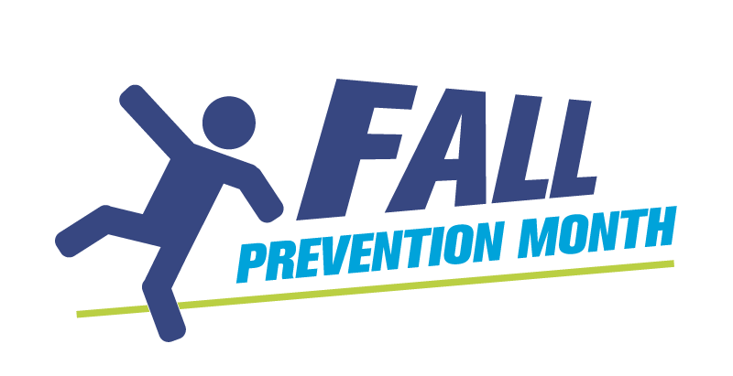
Fall Prevention Month Evaluation for Event Participants - Template

Thank you for participating in today’s Fall Prevention Month event! Please fill out this brief evaluation to help us make future fall prevention events even better.

What are 2-3 things that you learned today?

How will you use today’s information to prevent a fall for yourself or someone you know? (Check all that apply)
- I will tell others about the importance of preventing falls
- I will make personal changes to improve my well-being and reduce the risk of falling
- I will make changes to my home to make it safer
- I will get involved with my community to help prevent falls
- I will increase my daily physical activity to help improve my strength and balance
- Today’s information is not applicable
- Other, specify:

How likely are you to recommend this event/activity to someone else?
- Not likely
- Somewhat likely
- Likely
- Very likely

What could have improved your experience today?

