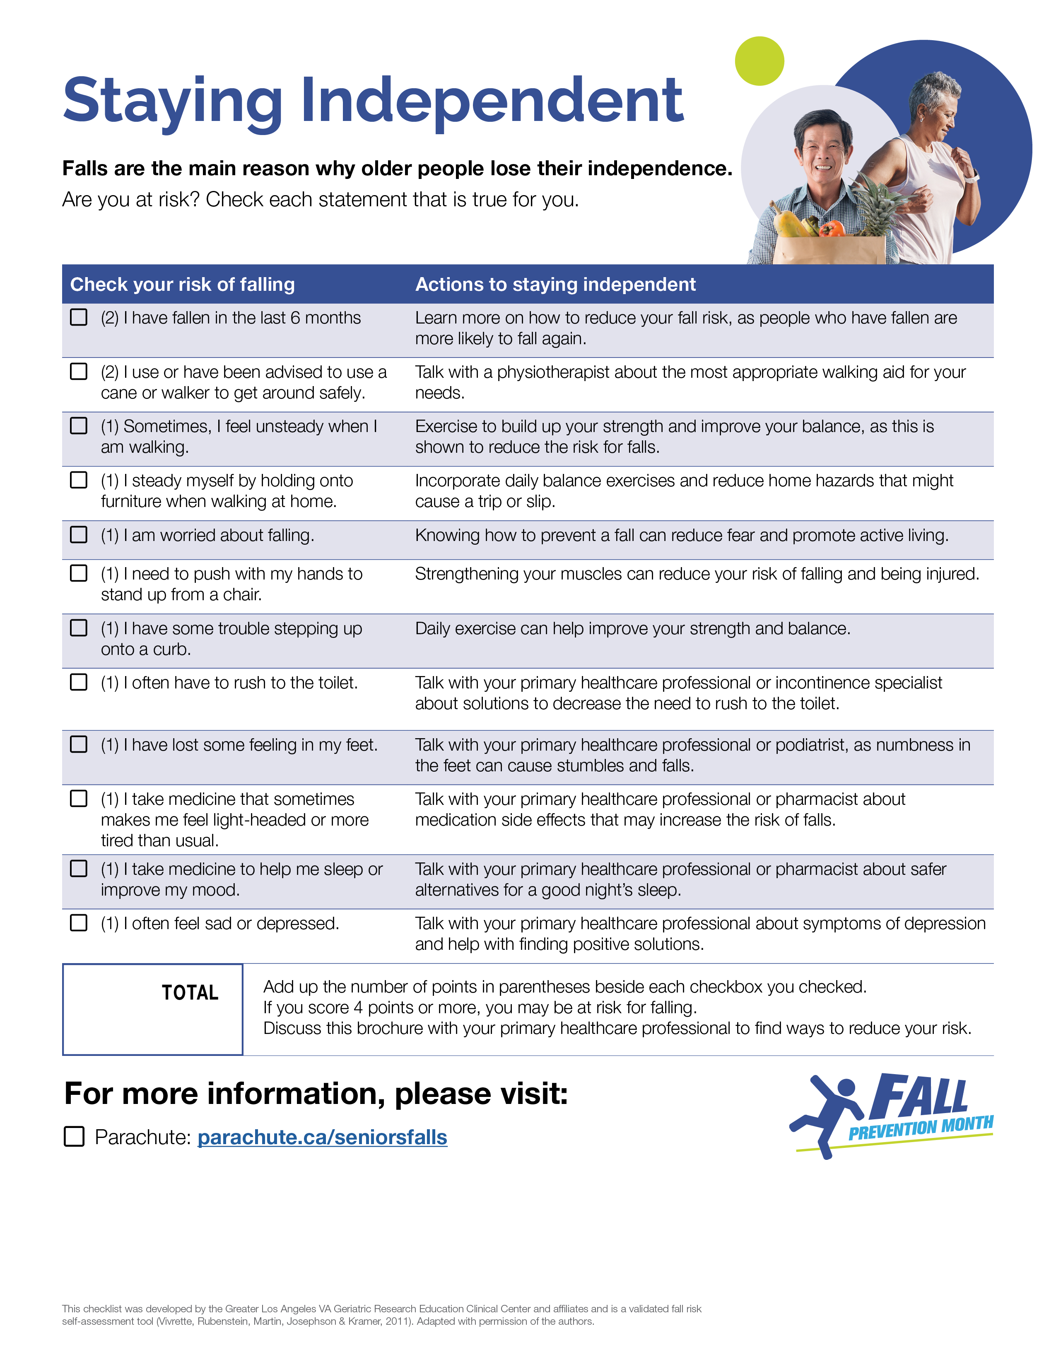
- [OPTIONAL: If your organization has a fall prevention landing page, include it here, or delete]
OPTIONAL: Replace with organization logo (or delete)

